**Daily Scrum or Standup Meeting**

Team name: Group 2

Scrum Master: Max Edwards

Date:_______________________________

| **Team Member** | **What did you do since the last scrum?** | **What do you plan to do before the next scrum?** | **What obstacles do you have?** |
| --- | --- | --- | --- |
| Satchell Fausett |  |  |  |
| Jared Hansen | Worked through React Django tutorial and updated activity diagram |  |  |
| Chase Miller | User Class diagram UML  Updated previous one |  |  |
| Max Edwards | Created Vehicle class diagram |  |  |
|  |  |  |  |

# Burndown

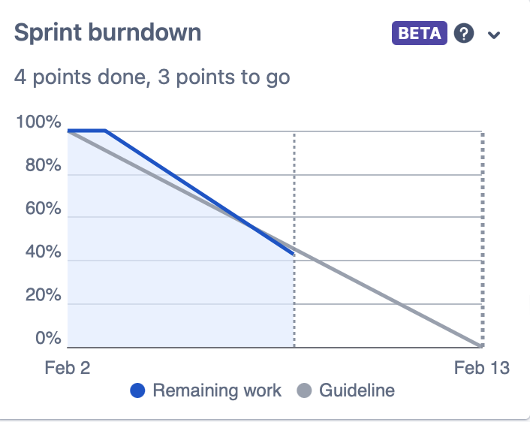

# Screenshot of you project board

